

Student Name: Charlie Coad
Student Number: 20102084
Course: Business Information Systems
Module: Big Data Analytics 2
CA No.: 1
Lecturer: Mrinal Chadha
Submission Date: 07/11/2025

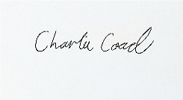
Signed: Date: 07/11/2025

Table of Contents
CA Part 1: Scala and IntellJ IDEA. 3
Task 1: 3
1A: 3
1B: 4
1C: 6
1D: 7
Task 2: 9
2a: 9
2b: 10
2C: 11
Task 3: 12
3a: 12
3b: 15
Task 4 18
4a: 18
4b: 19
Task 5: 20
5a: 20
5b: 22
Reflection of Scala Programming: 23

CA Part 1: Scala and IntellJ IDEA.

Task 1:

1A:
For task 1a I was instructed to create a Scala program that scans through customer feedback and extracts all the email addresses. First I defined this as an object known as “Task1a” and then created a value called text and inserted a long string of sample emails that I generated.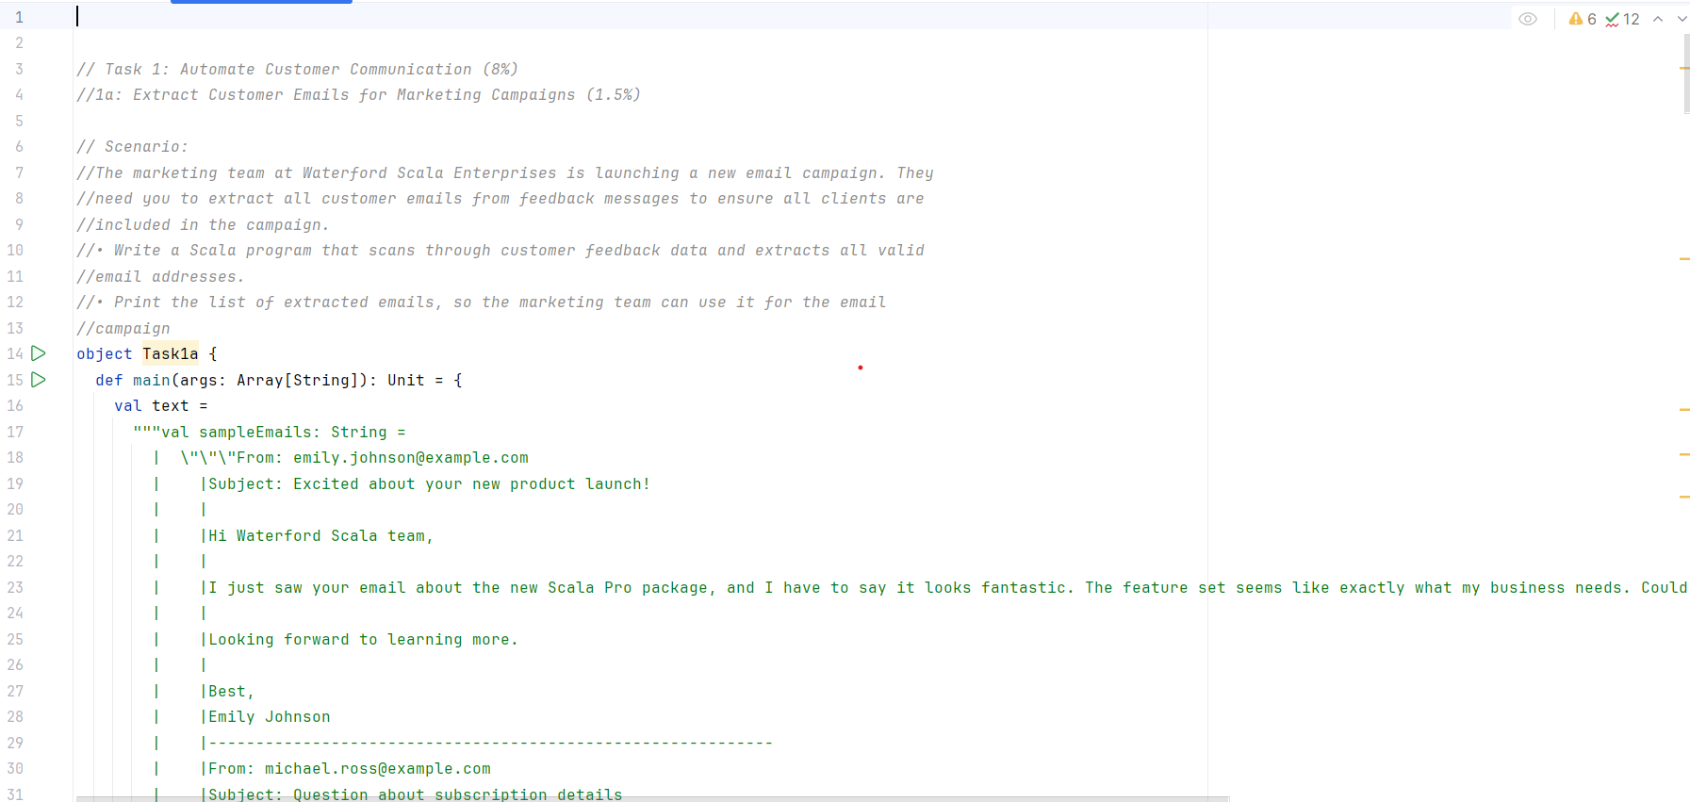

As the end of this long string I then wrote a value and defined a pattern that would identify any emails contained within the sample emails. I did this by having the pattern identify specific characters in a email like order.
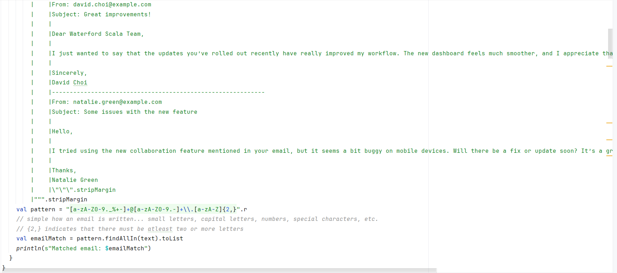

Finally I created a value called “emailMatch” where the pattern is activated with the function “finalAllIn” the text above and put these into a list. Finally I then asked it to print this list which resulted in the following.
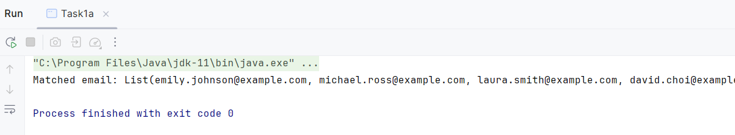

1B:
For Task 1B I was instructed to create a scala program that could detect PII such as telephone numbers and replace it with “REDACTED”. I did this by starting with creating an object called “Task 1b” and creating a value called paragraph and defining it as a string where I generated email data that would contain a phone number in each email.
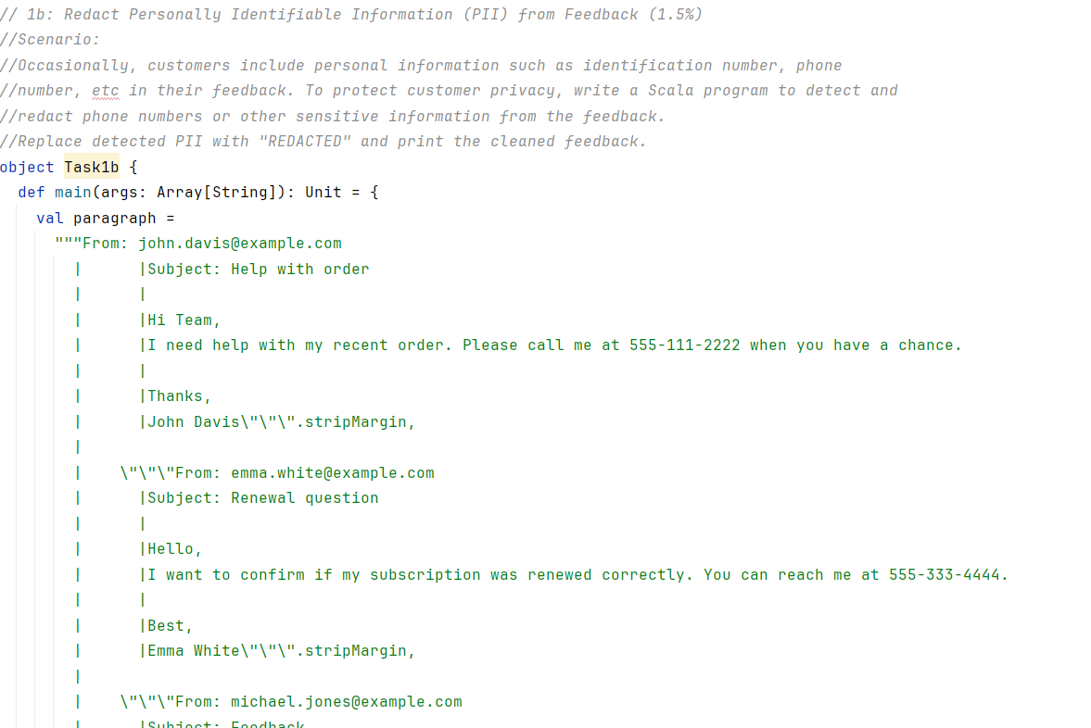
Next I created a value and a pattern called “Redactedphone” that would be able to detect for any phone number within the the string above. The pattern would specifically pick up numbers with 3 digits followed by a “-“and then another 3 digits followed by a “-“ and then another 3 digits. Next, I created a value called “cleanedemails” where this value would call the “Redactedphone” value to identify the phone numbers and then “ReplaceAllIn” in the paragraph value with the string “REDACTED”. Finally then I printed out my results:
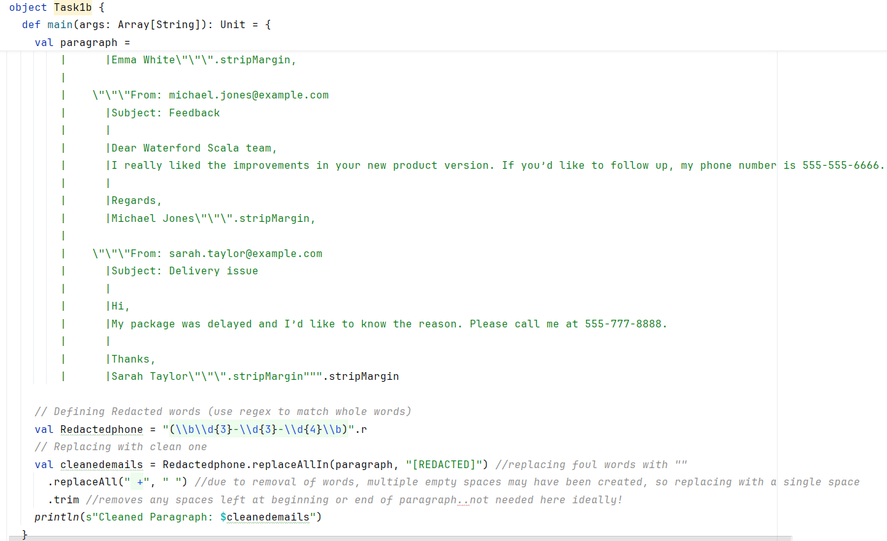
This led to the below result:
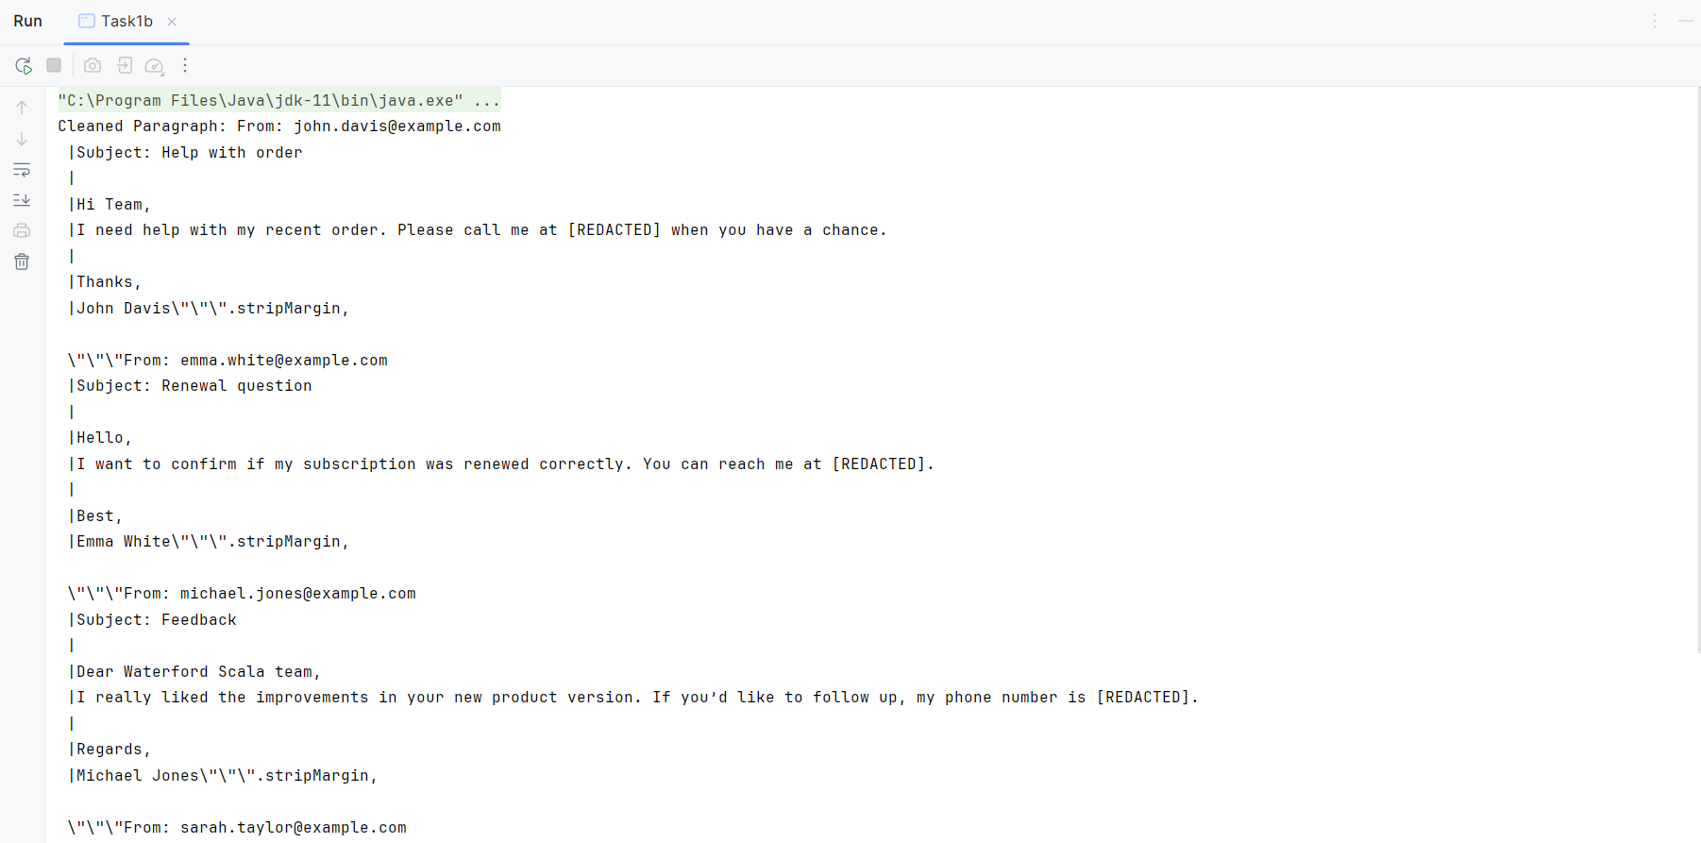
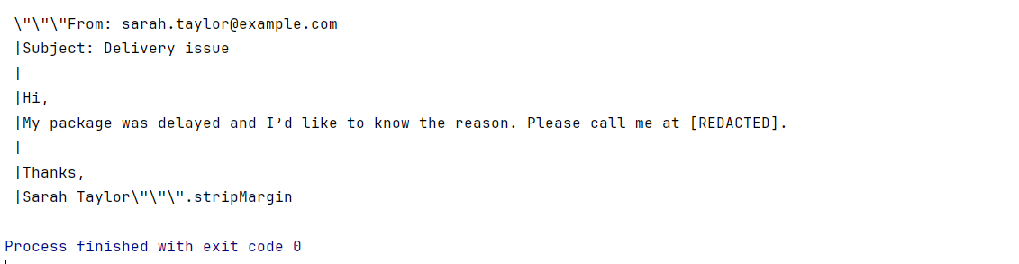

1C:
Task 1C asked for me to create an appropriate data structure in order to store 10 customer’s and their payment status’s, then to Iterate through the data in order to check the payment status of each customer. Then to send a reminder to the customer’s with specifically late payments by printing a message for each.
I began this task by creating an object named Task1c and then creating a value called customers and mapping it where a string will result in a string. Then using the map function to generate a string of 10 customer’s and associating each with a payment status ranging from either, “Paid” or “Late Payment”.
Then I needed to iterate through the map which I did using the “for” functions and associating that name will then be following by a status when referring to the value of “customers” Finally I then created an “If” statements where if the string “Late Payments” appears then to print “Reminder for customer” and then name that customer.

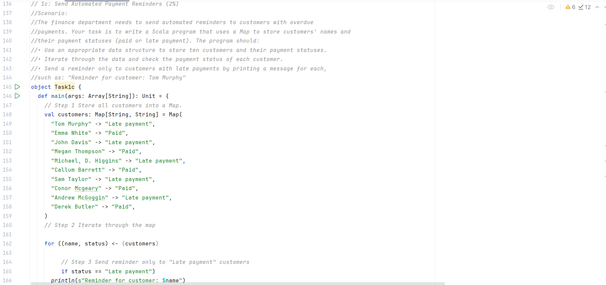
This results in the following:
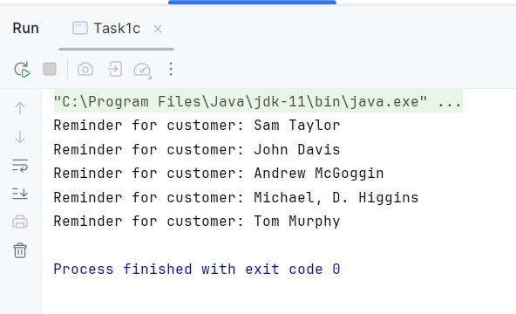

1D:
For this task I was to design an appropriate subheading based on the Task 1 tasks.
I decided to design a task where a business receives many emails a day, some of these emails may be detailing bills that need to be paid. I was to design a scala program that would collect all the bill figures and display them in a list.
First I began with creating an object called “Task1d” and creating a value called “Email” which contained a large string of emails that contained various bills a business needed to pay.
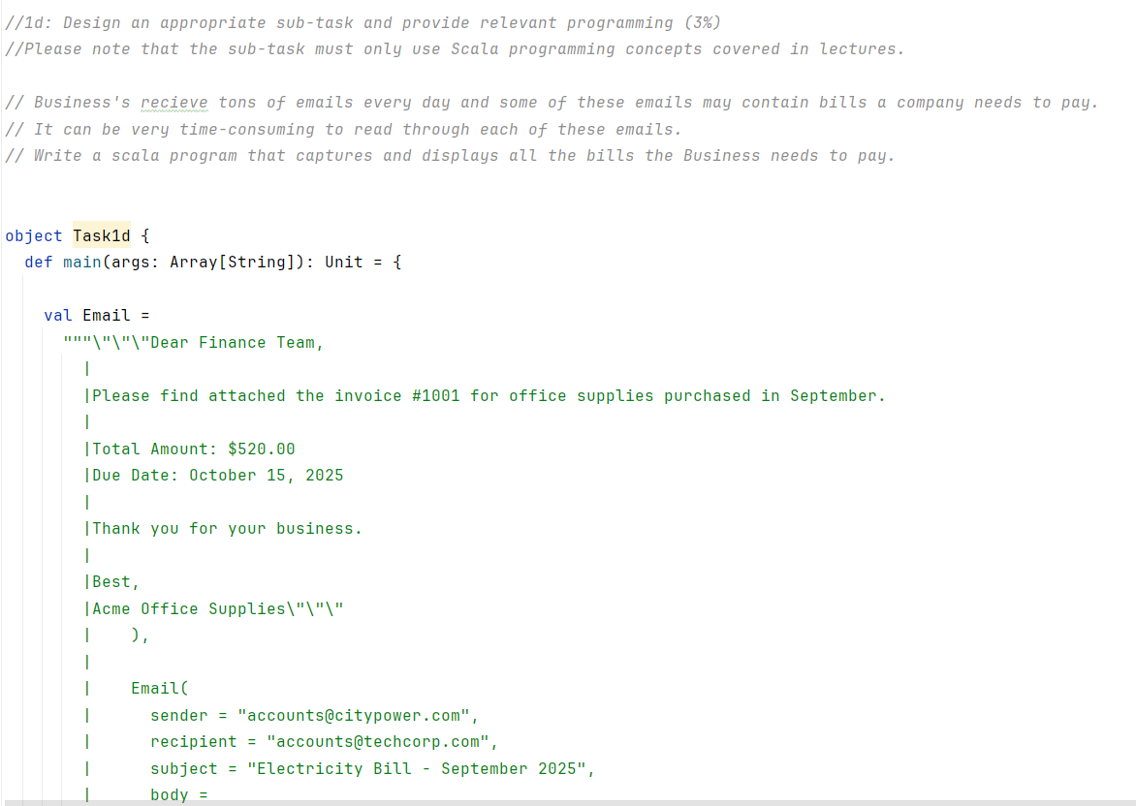

Next I began to create a value called “Bills” that would contain a pattern to identify bills within each of the emails by identifying the $ sign followed by 3 digits ranging from 1-9 and then 2 digits ranging from 1-9 to create a $xxx.xx. Finally I created a third value named “billsmatch” where it would use the “Bills” pattern to identify all of the bills within the email string.
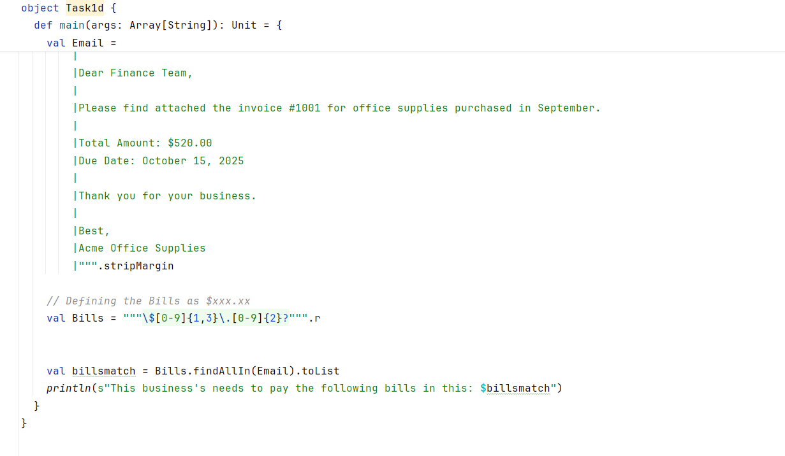
It would provide the below result:
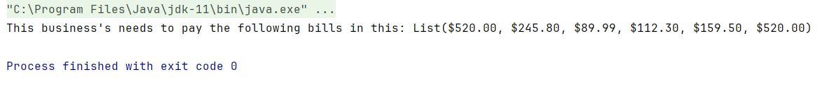

Task 2:

2a:
For Task 2a I needed to create a scala program that evaluates credit scores using the logic below. Then the system was to take a credit score and print the decision.
For this is I decided to first define the object as “Task2a” and begin by creating a value called loancredit that would be defined as any number. For the demonstration below. I have made the credit score 799. Then I created a match associated with that value where is the credit score was greater than 800, it would be approved, if it was between 799 and 600 it would be marked as “further review” and if the number is less than 600 it would be marked as Denied.
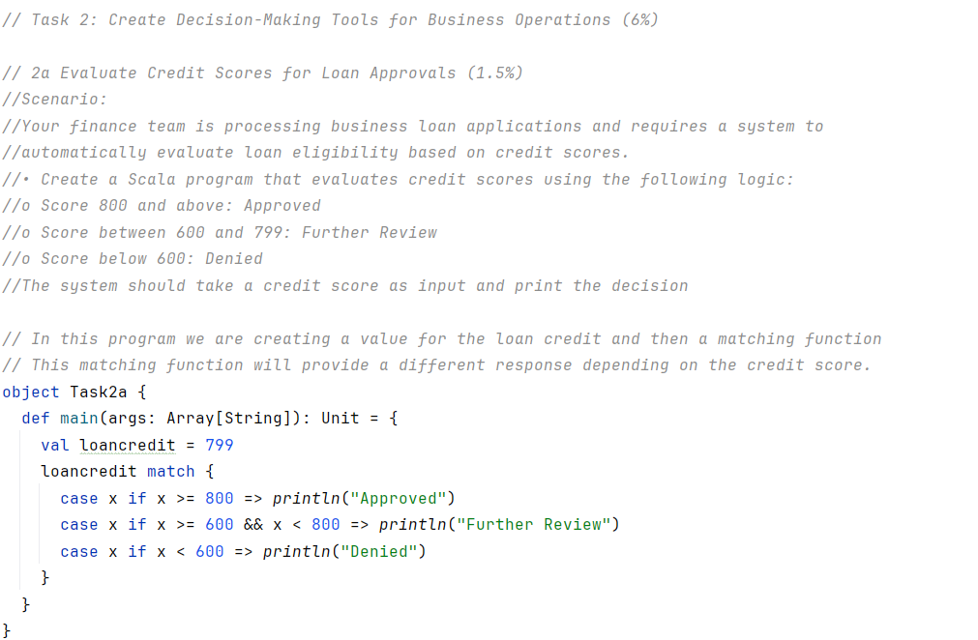
Below we can see the results of the credit score being 799:
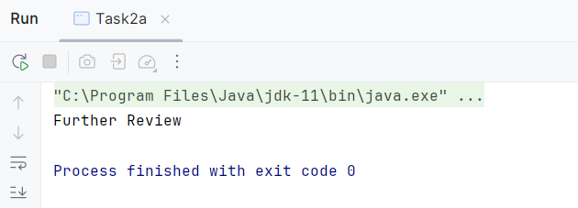

2b:
For Task 2b I was tasked with creating a scala program that would classify business project profits based on Profit Margins. I began this by creating an object labelled Task2b and then creating a value called “profits” and made a list of 6 random digits which would be the profits for this task. The I defined a function as “classifyProfits” that would provide input a profit and accociate that as an Integer. The function would identify the value “profits” and if a profit within the list was greater than 1000 outputs it as a string called “High Margin”. Else if the profit is greater than or equal to 500 or less than or equal to 1000 if would be labelled as “Moderate Margin” Any thing then lower then 500 would be labelled a “Lower Margin”
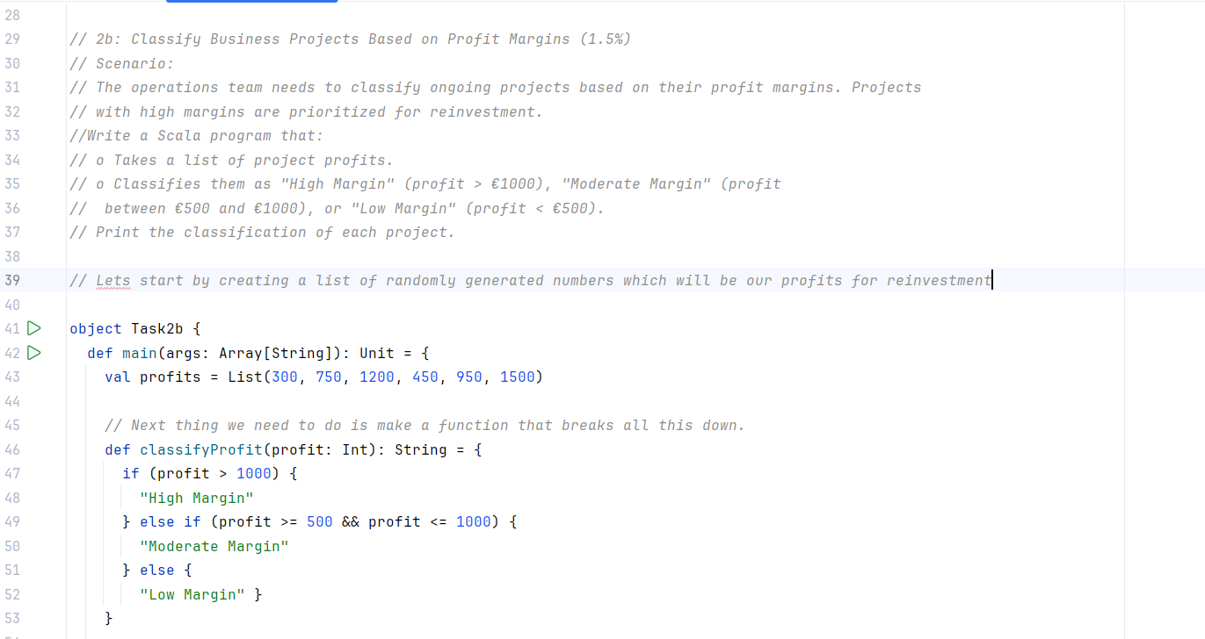
Next I created a value called “classifications” in order to apply the previous function to every profit within the list using the map function. Then I created a case where it would apply and associate the profit with each classification within the list and then printed it out in the string at the end.
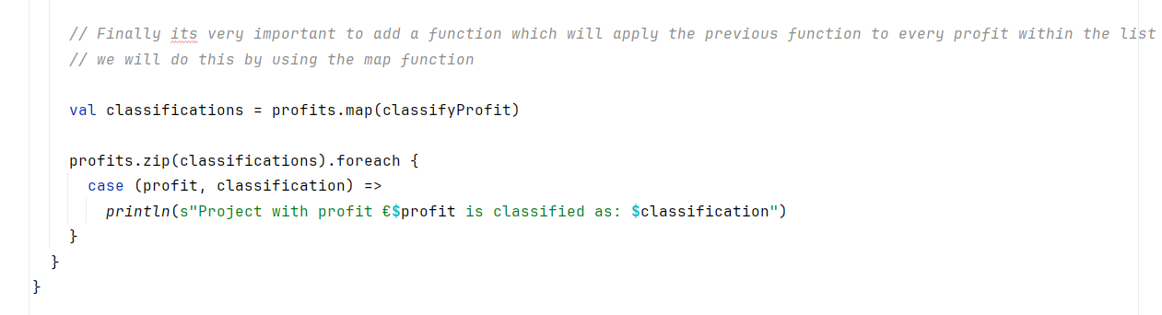
The created the below output:
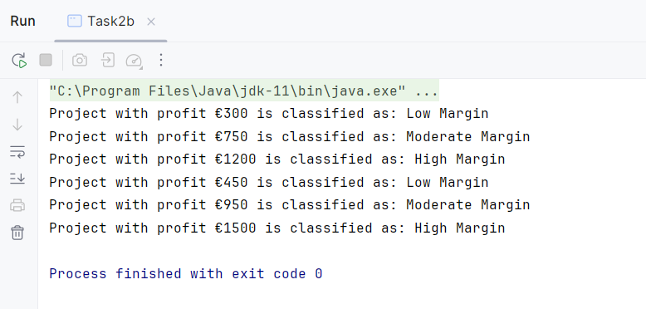

2C:
Finally for 2C I needed to create an appropriate subheading for Task2. I decided to create a scenario where a business needed to catalogue each order by weight and categorise them as either a small, medium or large order.
I began this by creating an object and labelling it as “Task2c” I started by creating a value called “weighted_materials” and creating a list of 7 different numbers which would represent the weight of each order. Then I created a defined function called “catagorised_weight” where each KG is associated with a string: Then the function would classify any KG over 75 as a large order, any KG between 45 and 75 as a Medium order and everything below 45 as a small order.
Finally I needed to map the weighted_materials function to the “categorised_weight” function.
Then I would use the case function to associate the list of numbers and the categorise in the functions a to print out the finaly output as seen below.
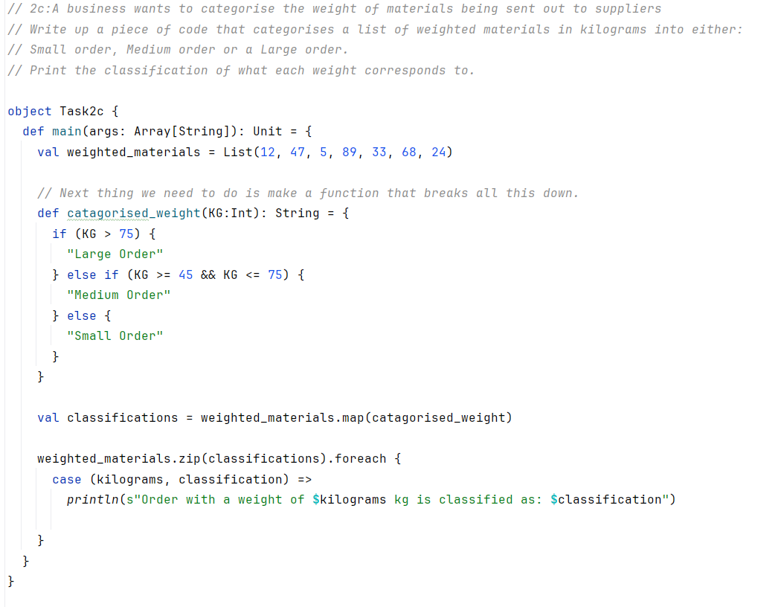
The Output of this task:
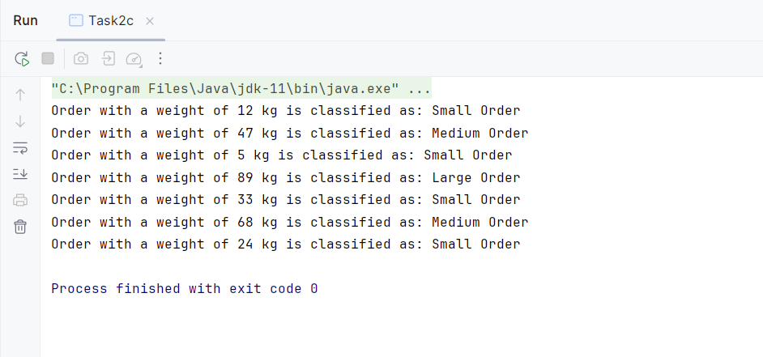

Task 3:

3a:
In this task I was instructed to create a program that handles basic operations for products which included displaying the products details and simulating sales.

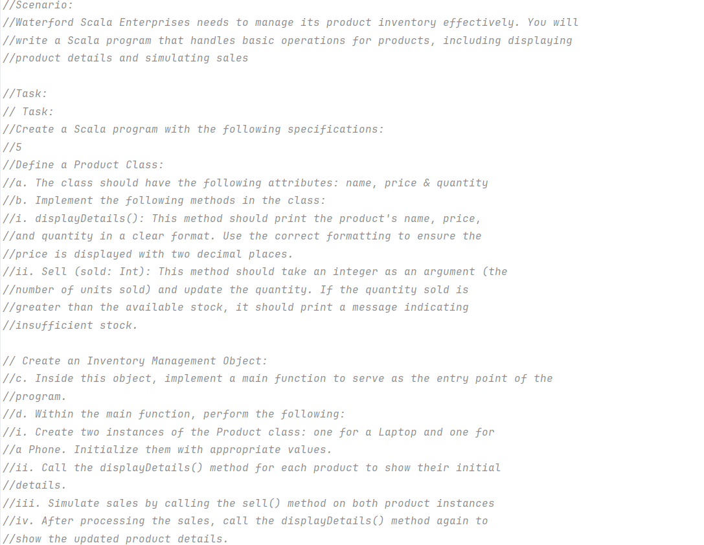
I started by defining the class as Product where I needed to define 3 variables named “name , price and quantity” “name” was a string, “price” was a double and “quantity” was an Integer. Then I defined a new function calling is “displayDetails” where once the strings were called, it would call its corresponding variable and display it in its current status. In this case “name” would call and display name, price would call price and quantity available would call quantity.

Next I made a new defined function called “sell” which aimed to simulate the selling of the product. It did this by defining Sold as an integer and if sold less than quantity was, it would then take that integer away from the quantity value and print that it had sold that many quantities. Otherwise it would print that there is not enough stock.
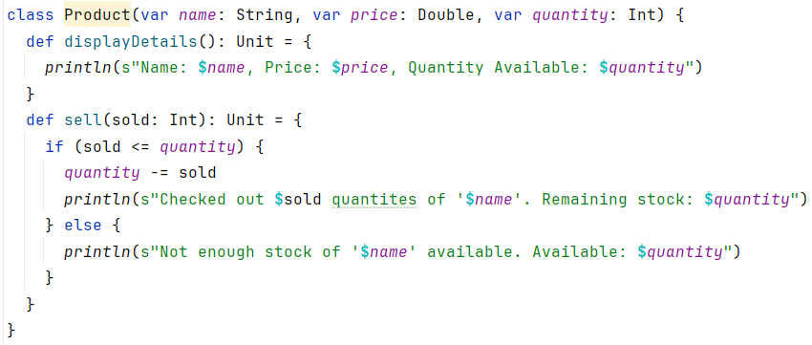
Next I needed to define the object which I was instructed to call “Inventory_Management” then I created 2 new values called Labtop and Phone which were given the new function to associate them with my class “Product” and defining Name, price and quantity within. Now I could finally carry out the functions and commands by displaying their details, then simulating a checkout by selling a specific amount of them and then displaying the details of the values after they had sold a specific number of quantities.
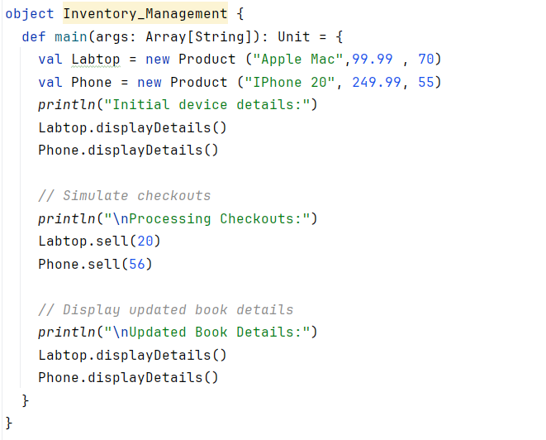
Results of this output:
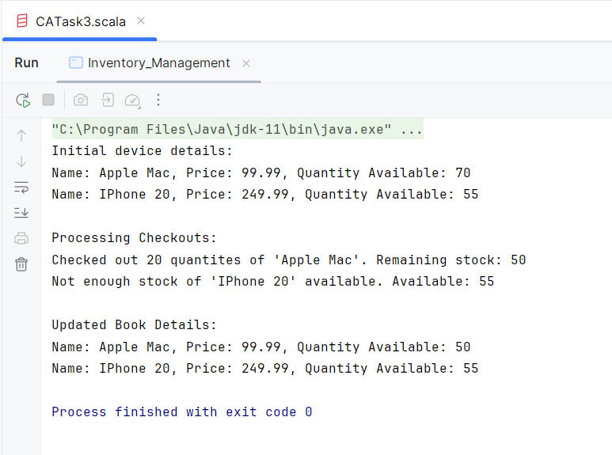

3b:
For 3b I was instructed to create a sub-task. For this subtask I decided that I wanted to add to the above’s program in my own way by creating a new functions and make a better simulation of how a product is sold. In this scenario a record shop wants to sell its items and add promotional discounts to their item.
Similar to the above task I needed to create a class this time being called Item and defining the name as a string, the price as a double this time and a quantity as an integer, all of which we defined as a variable. Next I made a function to display the details of the items and then moving on to create a selling function that would simulate the items being sold and the quantity decreasing as a result.
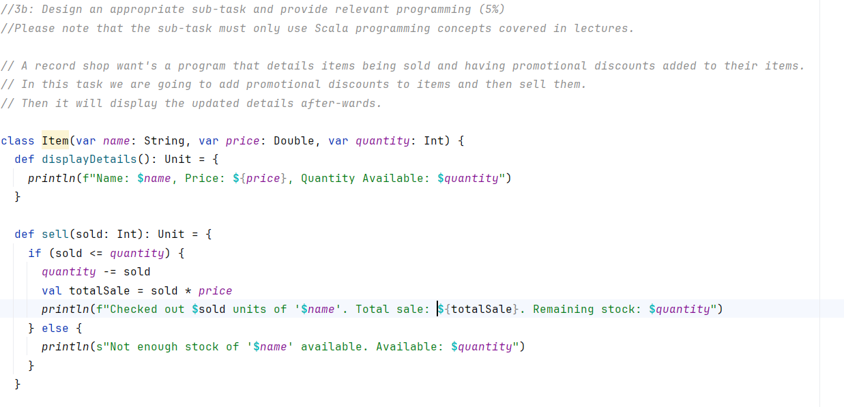
Next I created a new function called “applyDiscount” I defined percentage as a double and made an if statement that the percentage needs to be between 0 and 100 otherwise it will result in an error message. Then if it is between 100 and 0 it is multiplied by the price and divided by 100 in order to determine the percentage of the amount of money to take of the price. Then a message is printed to name the discount and the new adjusted price.
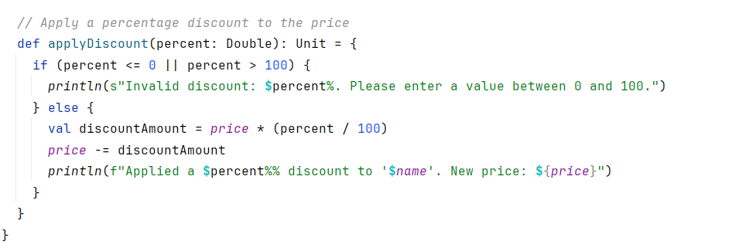
I then defined my object as Task3b and created 2 new values called CD and Vinyl and defined their attributes of Name, Price and Quantity. Then I created a series of different commands that would perform the functions created earlier onto the CD’s and Vinyl values. In this case I displayed the initial details, then applied the promotional discounts, then simulated the customer checkouts and finally printing the new adjusted prices.
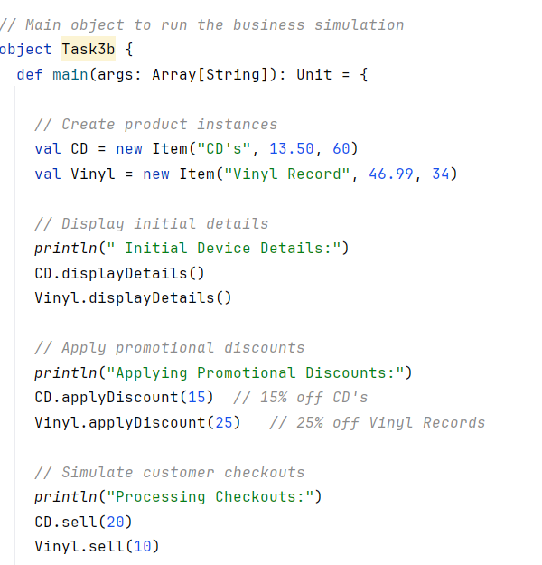
The Results of this output:
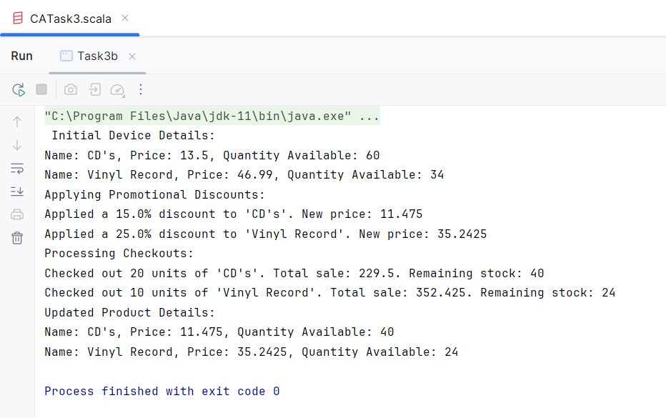

Task 4

4a:
For this task I needed to create a Scala function that aimsed to take a list of daily sales and calculate the total weekly revenue based on that list by adding them all together.
First I defined my object as WeeklySalesApp and defined a function called “showRevenue” I the associated totalRevenue with a double and print before accessing total revenue… before anything happens to simulate a system processing. Then once the computation happens it will print the total weekly sales revenue is and then the Total Revenue which will be displayed as a double
I then created a value called daily sales which was the List of the sales from that week.
Next I created the Call-by-Name expression that called the showRevenue function to begin printing and then calling the dailySales value and summing it together
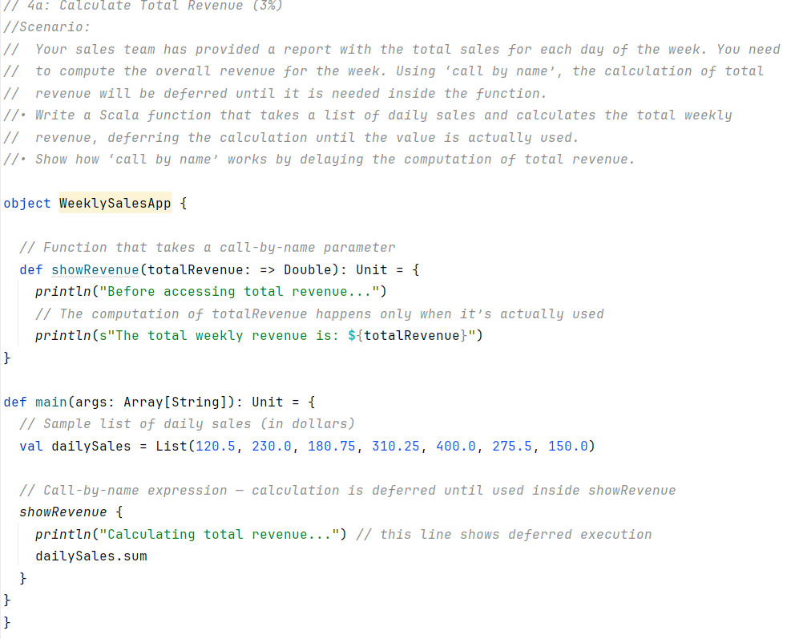
The Results of this output:
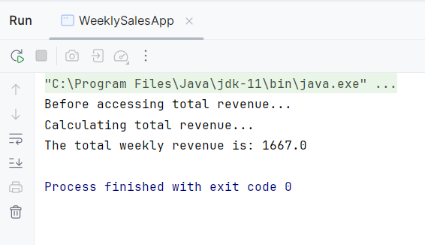

4b:
For 4b I was to create an appropriate sub-task. The subtask I created would be a program that would order new stock if stock levels went under a specific threshold. For this example it would be 50. Using the Call-by-Name expression.
I began by creating an Object called Reorder and then defined a function call checkInventory that defined stocklevels as an Integer. Next i created an if else statement where if the stock levels were less than 50 then the reorder name would be called otherwise the function would bring a string saying that the stock level is sufficient and no reorder is needed.
Next I called that function and for this case I inputted the stock level as 45. This then called the reorder function which will print the following “Stock levels are currently under the required threshold of 50 units, reordering stock from supplier…”
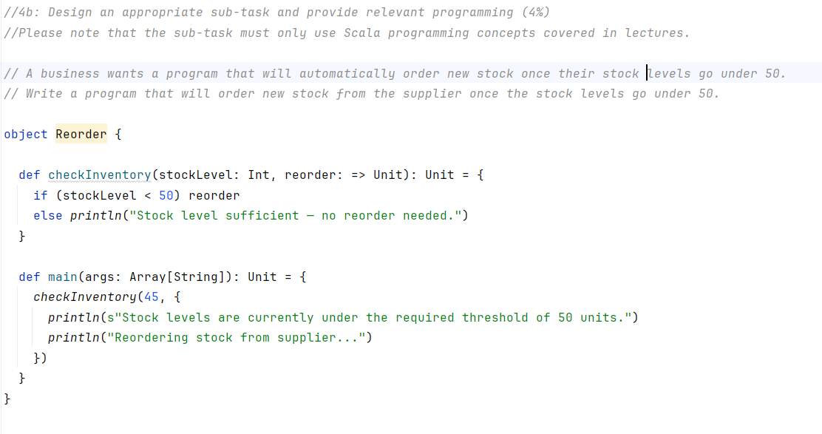
The results of this output:
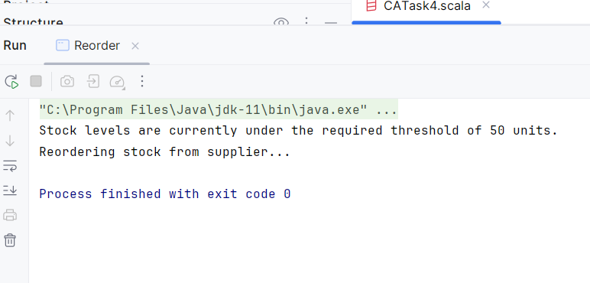

Task 5:

5a:
For this task I was instructed to write a solution that to help a business optimise their project budgets by creating a program that will perform basic functions to provide them with potentially different budgeting strategies by increasing and decreasing budgets by percentages.
To begin I defined this object as Budgeting_Strategy and defined and created a few simple high-order functions called “Increase_budgets”, “decrease budgets” and “noChange” These aimed to increase and decrease the percentages of specific proposed budgets. NoChange aims to just display the budget and not change it in any way.
Next I defined a function called “applyBudgetAdjustment” which would aim to apply these percentage changes to the list of proposed budgets rather then just 1 or 2.
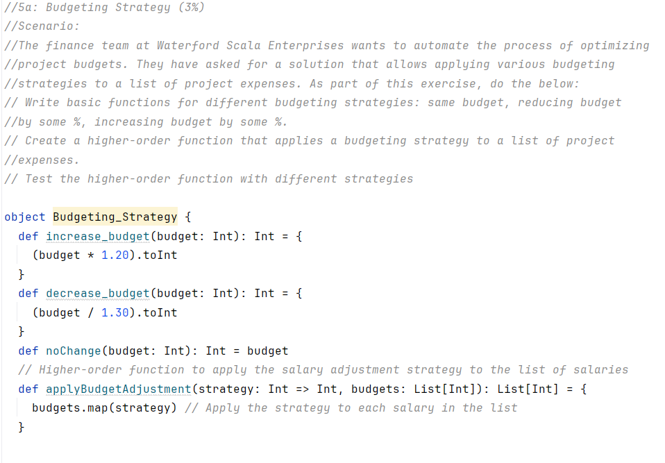
Next I created that very list of proposed budgets. Then I created 3 values that would utilise these High-order functions. The first value named “increasedBudgets” would apply the budget adjustment function and then increase the budgets by 20%. The second value called “decreasedBudgets” then decreases the list of budgets by 30%. The third value then print the list of budgets with no adjustments or changes as to use for comparison to the previous 2 values. These would then price the results of the budget adjustments.

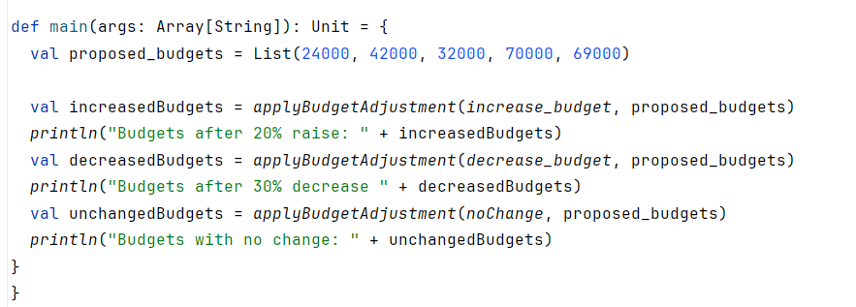
The results of this output:
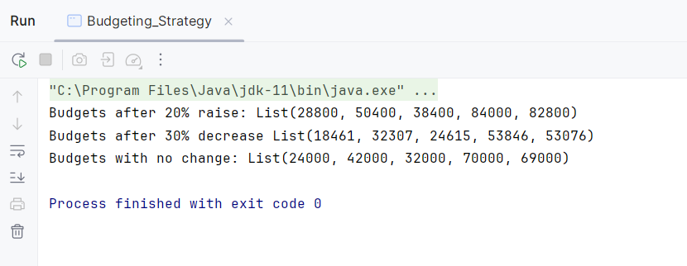

5b:
This task I am to design an appropriate subtask.
For this task I decided to create a scala program where a business needs to increase the prices or their digital products prices by 40% and decrease their organic products prices by 25%.
To start this one I created a new object called Pricing_Strategy. Next I created a few high-order functions that would increase the prices by 40% and decrease prices by 25%. After this I created another function called “applyPriceAdjustment” which aimed to apply all of these adjustments to every price within a list.
Next I created 2 values representing the digital products prices and the organice products prices.
Finally I created 2 values named “increased_price” and “decreased_price” which aimed to apply by high-order functions to the list of separate prices. These would then price the results of the price adjustments.
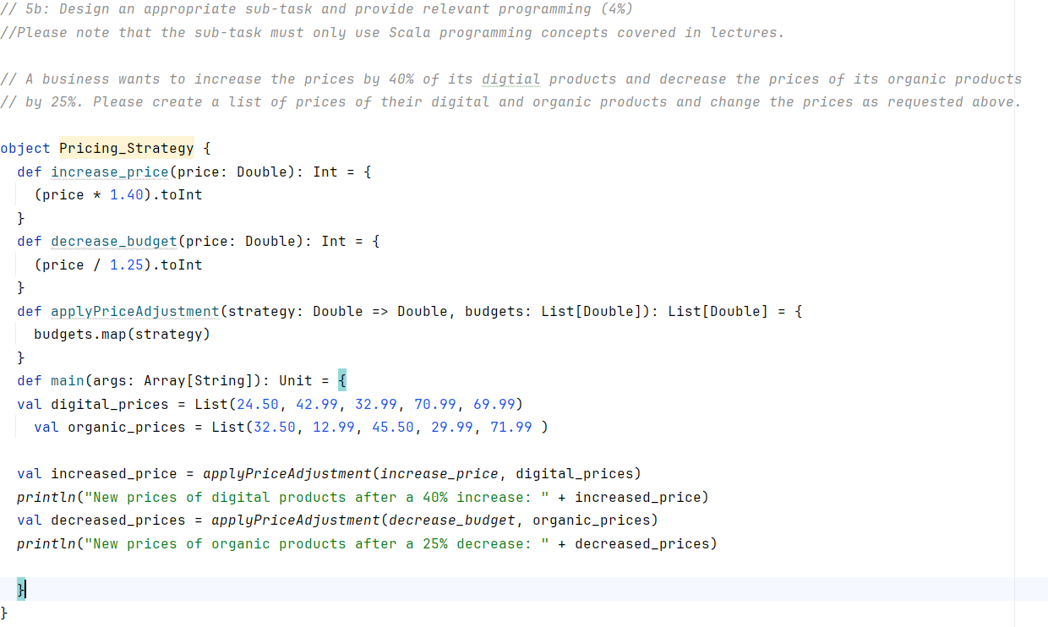
The results of this output:
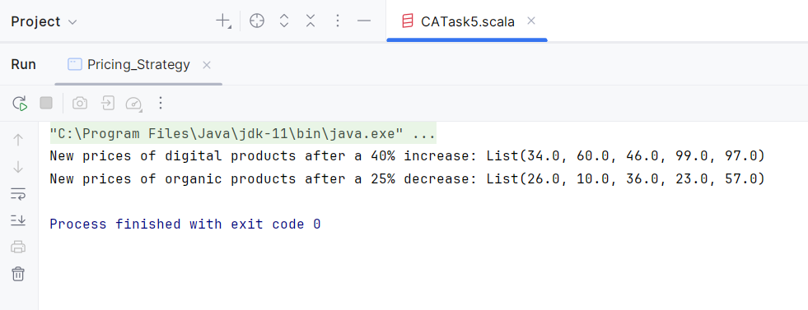

Reflection of Scala Programming:
Scala programming is a very powerful tool when it comes to decision making, automating tasks and enhancing data processing within a business environment. This is because it allows the business to calculate, analyse and manipulate data in order to re-structure and better interpret the data being presented. With a better understanding of the data being analysed it can lead to improved decision making. This can range from analysing sales data, employee data, supply data, etc… This data can be inputted into Scala and programmed to provide an output which is typically the output of analysing or calculating the data. This output then gives the business vital knowledge that allows them to proceed with decision making.
Scala can also be used in order to automate tasks. This means that tasks can be coded into a software using Scala (typically in the form of functions) in order to preform simple actions or calculations. These tasks (depending on the complexity) can be very useful for a business as it saves the business time by streamlining specific processes such as calculating profits, salaries, pricing, budgets etc… In the case of my tasks for this CA, I was utilising Scala in order to automate simple business related tasks such as calculating and adjusting the prices of products or categorising orders by their weight.
Scala programming can also enhance data processing, this is because Scala is made to process large amounts of data. These large amounts of data can be inputted into Scala in order to be analysed and calculated in accordance to the business’s requirements. Throughout the course of my tasks I utilised long strings of email data which contained emails address’s and messages and Scala was about to process all of this data quickly in order to redact confidential data in the output.
The tasks I performed in this CA relate to real-world business challenges because the tasks I preformed solved challenges that business’s face on a daily basis. These range from calculating salaries to classifying and categorising profit margins. This is data that is vital for business’s to understand in order for them to succeed and continuously improve.

